**Chapter 60 – Year 2012**

**Email to family: Dear family, about Easter Egg Hunt, Snowmobiling at Trail Creek Lodge, etc. 2012**

 It has been great getting together with most of you lately.  Thanks for the Birthday dinners for dad and time spent with you.  We've enjoyed being with our newest **grandbaby, Rachel Lyn**, and her parents and brother. Dad wanted to celebrate his birthday at Lava and soak in the mineral tubs.  He also wanted to go snowmobiling, so he checked around and found the best place to do that was at Soda Springs in Idaho which is just 25 miles from Lava.  Sandi and Nick went with us and we had a great time.  We spent one night at Lava and one night at Soda Springs.  The lodge was so fun there at Soda Springs.  It is a bed and breakfast.  We were the only ones there at that time, so it was really fun.  The owner gave us a super deal since we were renting a double snowmobile for $120.00 and since we weren't there on a weekend.  He gave us 2 rooms for $40.00 ($20.00 for each couple) and that included a wonderful breakfast of sausage, eggs, hash browns, toast and orange juice.  The lodge had a large screen TV with a DVD player, hot tub, fireplace, tables to play games, etc. plus 25 miles of groomed snow mobile trails with lots of hills and valleys to play around on.  The four of us plan to go again next year, and we'd like to invite any of the rest of you to go with us.  We will stay the two nights at the Lodge in Soda Springs rather than stay one night in Lava.  They have several snowmobiles to rent.  If you rent a snowmobile, they furnish the snowmobile outfits free.   We had all of that for Wednesday afternoon, Wednesday night and most of the day on Thursday.   It only cost us $76.00 a couple, (we shared the cost of the snowmobile and the rooms).   Sandi said it was the most fun she has ever had snowmobiling.  This was the first time Nick has been snowmobiling and I asked him if he liked it and he said he loved it.  If we go during the week, and if most of you wanted to go, we could rent the lodge for a good price.  It has 7 bedrooms, plus lots of other space for sleeping bags.  Let us know soon if you are interested as we need to make the reservations soon.  The owner says that many people make reservations a year in advance.

Dad's Christmas or birthday gift from you - Dad's guided fishing trip in August is another fun trip we're looking forward to.  We will take our boat and tent trailer and plan to stay the week at Flaming Gorge reservoir.  Dad's guided trip for the big fish is for part of a day, but since we will be there, we wanted to stay a week.  If any of you can come, we would love to have you.  Sandi and Nick will be there as he will be on the guided trip too.  Not sure if they are staying the entire week. That will be the week of August 4th through the 9th.

I'm sure we will be going to East Canyon Reservoir again at least once or twice this summer and maybe to Willard Bay and take "Great Big Mable", so hopefully some of you can some during those times too.

Shellie and family will be coming up again in July, so we will have a "Girl's Day Out" again.  We'll plan that later, but if you girls have any ideas for what to do or where to go, please let me know.  Shellie and family always like to go to Lagoon while they are here, so maybe some of you could go with us there too, plus we will have a family barbecue.   We will have at least 2 or 3 more Saturday summer barbecues in our back yard too.  If any of you have ideas for fun things to do as families or as couples, let us know that also. Well, we hope you all have a wonderful Easter.

 I have heard about the "wheat shortage" from different people.  Maybe you have heard about it too.  I had heard that the LDS mills still had some, but I was talking to a friend yesterday in church and she said they are out too.  She and her husband volunteer at the church mill in Kaysville every Wednesday.  She said there was a rush on wheat and it is gone now.  She said they had a truck come in last week and people knew it was coming in and within a few hours, it was all gone.  She said she checks on the internet regularly and found it is a major concern worldwide.  We hope you have already got some put away for your food storage.  Maybe it isn't as big a concern as she and others are saying, but maybe it is.

Come see us when you can.  We know you are all busy, but you don't need an invitation to come.  We're always excited to see you when you can.

We sure love you all.  Mom & Dad, Grandpa and Grandma

Ken and I are family history consultants for our ward, so we have been able to help many members get registered at new family search and begin doing their family history. We just finished teaching a family history class and will start up another one in January.

**My siblings and I were in charge of the Bushnell Family Reunion held in August**. It is our grandparent’s descendants on our mother’s side. It is held for three days every three years. It was held in Tropic, Utah and there were 150 in attendance. It took a lot of planning and effort to prepare the food and activities, but everyone had a good time, so we were happy. **Ken & I also hosted the Glendon Porter Family Reunion, which are my parent’s descendants. It was only an afternoon and evening and we held it in our back yard. We had a good time at this reunion also.**  Ken & I were able to go on some camping and fishing trips with our children and their families and we surely enjoyed these vacations.

Ken’s brother, Bob’s wife**, Carroll, passed away on August 12th.** We have missed her, and Bob is very lonely without her. She had a massive stroke and went into a coma. She was only in the hospital a couple of days when she passed away. Carroll had other health problems, plus dementia, so we are glad she didn’t have to suffer longer.

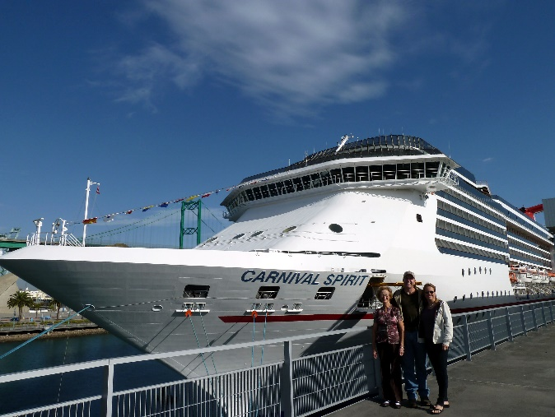

**HAWAIIAN CRUSE WITH SANDI, SHELLIE & ROY – December 1 – 17, 2012**

We got up at 3AM and got Sandi’s luggage packed into the car. When we finished the car was really loaded. We had six suite cases, each weighing about 50 pounds, plus the three of us. We left Tooele at 4:30AM with some winds. We stopped at St. George for rather to eat. There were some winds but no storm. Before getting into California we saw snow on the high mountains, but the roads were good. With the G.P.S. we were able to travel right on to our motel in Long Beach. At the motel, we went out to soak in the hot tub and a swim in the pool, Roy and Shellie were late leaving home and when they got to the California Border they were held up for 1 ½ hours getting through the Border inspection. It was 10PM when they got to the motel. We visited with them for a little while before we all went to bed.

We went in for breakfast, at the motel as breakfast came with it. It was very good.

We got to the pier at 1PM but the ship had been two hours late getting to the port, so they were late starting the check in. It was after 7PM when the ship left the dock. We toured some of the boat and then went to dinner. Dinner was very good, and they sure are trying to take care of us with Ken and my diet needs. After dinner we went exploring the ship. It is quite a boat. After leaving Roy and Shellie, Sandi, Ken and I started for our room. On the way we passed a dance hall, so **Ken and I danced for a few minutes.** 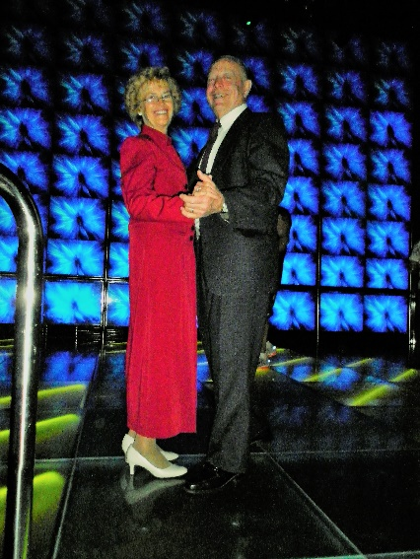We have always loved to dance.

Ken woke shortly after 4AM and mainly watched the ocean waves. After the sky started to lighten he saw tuna surfacing. Sandi and I came to the port window and watched them with him. The waves are quite large and the ocean very rough. It is interesting to walk around with the ship swaying. After a good breakfast, we attended a ballroom dance class and really enjoyed that. Sandi and I did some research of shore activities. When we came back, we went to the dance lessons. We then had some Suchi which was my first time. We came back and got ready for dinner. We met Roy and Shellie at the Monarch room and played Mexican Train Dominos until dinner time. We stayed for a show 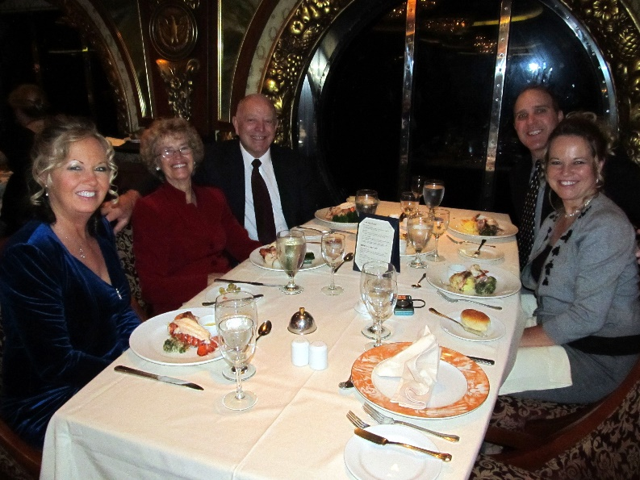but I wasn’t very impressed.

We didn’t have a lot of activity except meals. We watched the movie “The Man Called Peter” using our computer and projector. It makes it a little crowded with 5 of us in our room. This afternoon we attended a dance class. We then came back and dressed in our best for the dinner this evening. We then went for pictures to be taken. They had many photographer’s taking many poses so that everyone had lots of chooses. We did have some time to dance in some of the Ball Rooms before going to dinner. This was the captain’s evening in the dining room. He spoke for a minute, but we really weren’t very impressed. After dinner we attended Show Time and the Big Band. We were tired but when we went past the Club Cool room we couldn’t resist going in and dancing until mid-night.

Ken and I went walking around the ship as the weather was much warmer today. It was fun walking all over the upper decks. The sun broke through the clouds and everyone was out sun bathing. We were able to use the swimming pool and they we quite warm. Sandi came and said that they wanted to play miniature golf, but I was tired, so I went, and Ken took a nap. An hour and a half later I came back and woke him. We went to a dance lesson but didn’t stay very long as it was basic Fox Trout steps. We looked at the pictures that were taken last night and picked some of what we liked. We came back to our cabin and watched the movie “The Ultimate Gift” and we all enjoyed it.

(This is taken from Ken’s journal – so he is writing this now). This morning when I woke my pain level was up. I will have to be stricter with my diet. After breakfast the five of us played the game “Trans America” and quite enjoyed it. Sandi and I attended the dance class. While we did that Mae went to our cabin and lay down for a while. We then went up to Roy and Shellie’s cabin and played “Mormon Bridge”. After getting started in the card game we attended the Magician show. Following dinner, we finished the card game we started earlier. It was late when we were ready to go to bed.

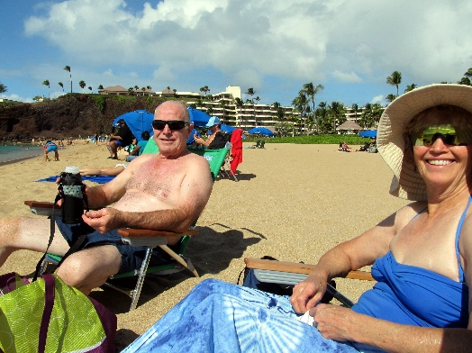We came into port about 10AM. It was neat to see us come into the island. Sandi, Mae and I took a bus tour to the Hawaii Volcano National Park. Roy and Shellie took a helicopter tour of the Island. On the way we stopped at the Mauna Loa Macadamias plant and saw how they processed the Macadamia nuts. We also bought some packages of the nuts for gifts and to eat. After returning we went to a show on board the ship and then to dinner. After dinner we came back to our room and the five of us watched “Heaven Can Wait” which was a cute show.

We arrived at Maui at 8AM and disembarked shortly after in order to be on our tour by 10AM. Sandi, Mae and I rode the tour bus to the Sheraton Hotel where we walked through their facilities to the beach. It was a beautiful sandy beach where we enjoyed the warm sun shine. We also enjoyed snorkeling and seeing the many fish. Back at the ship, we then went to eat and then attended a Hawaiian dance show.

This morning we were at the Island of Oahu. I woke with the pain level very high. We went for breakfast and then left for the tours. Mae, Sandi and I went on a bus tour of Diamond Head. Most of the stops, I stayed on the bus because my feet and legs hurt too much to walk very far. The tour guide was very good and we did enjoy the trip. I have really watched what I have eaten today but tonight I’m still in a lot of pain. When we came back to the ship I got me some chicken to eat and went to the cabin. Mae and Sandi went shopping. I took a nap. Mae and Sandi had a lot of fun shopping this afternoon. This evening I watched a show on TV. Mae and I went to bed early.

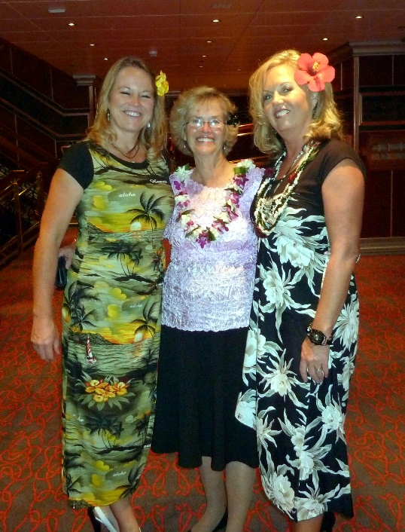 This morning we were on the Island of Kauai. We set the alarm and was up at 6AM in order to be ready for our shore excursion at Kauai. Mae didn’t sleep very well last night because she was worried about me. I do feel much better today, although my feet are still tender. Roy and Shellie went four wheeling in the mud. Sandi, Mae and I went on the Waimea canyon & Wailua river boat tour to the Fern Grotto. It was a very beautiful ride up the river and then when we got up the canyon we docked and had a short walk up through beautiful jungle trees and plants to a cave. They only let us go to a view area because the hurricane had damaged the cave and loosened the rocks above making it dangerous to go further. When we got there the tour was to show and teach some Hula but it started to rain very hard. Finally, when it broke they had everyone return to the boat where they gave us the show. It was good that they did because it rained more. This area has more rain than anywhere on the earth receiving over 400 inches annually. It was a very worth wile experience. When we returned Mae and Sandi again went shopping. I came back to the cabin and took a nap. This evening Roy, Shellie, Sandi, Mae and I went to the evening show, which was a Juggler Entertainment. We stopped for more photo shouts and went to dinner and then quit for the night.

Today we are on the Island of Hawaii, city of Kona. We had to get up early in order to be on time for our tour. The weather was very pleasant. Sandi, Shellie and Roy went on a tour where they were able to swim with wild dolphins. They also saw a hump back whale. Mae and I went on a walking tour in the city. My pain level is high, and my feet and legs hurt. For breakfasts I have been having scrambled eggs but as I finished eating this morning it dawned on me that they probably are using powered eggs mixed with water and milk. That was kind of dumb on my part. The tour was very good but by the time it was over my pain level was high. Mae and I set on a bench and ate a boiled egg. We were going to go through a museum when Sandi called and said that they were back from their tour. We waited for her to join us. I decided to return to the ship and let Mae and Sandi continue in town. I carried several items back with me so that they wouldn’t have to carry them around town. When I got back to the pier I met Roy and Shellie. I also took their snorkeling equipment back to the boat with me, so they wouldn’t have to pack it with them. After dropping the extra items off at our cabin, I then up to the dining area and got something to eat. I then came back to the cabin and I fell asleep until Mae and Sandi came. We departed Hawaii about 4PM. As soon as we got out to sea the seas seem to become quite rough. We put on the DVD movie “Golden Plates”. It wasn’t finished when Shellie called just before 7PM. She reminded us of this evening’s entertainment. We paused the movie and went up to the theater. We were able to find Roy and Shellie there. The show was a musical and dance production that was very good. After dinner we ended up getting more pictures taken. My pain level was high so I found a place to just sit. When Mae came we went downstairs to our cabin. Sandi wasn’t much longer coming to the cabin. We watched the rest of the movie and really enjoyed it. Roy and Shellie came down to get their scuba gear and while they were here I had Roy give me a Priesthood blessing.

We are back on the ship. We slept in this morning. I slept fairly well although the pain level in my feet, legs and hips is quite high. I didn’t get up for breakfast, but Mae brought some breakfast down to me. Mae isn’t feeling very good this morning. She seems to have some congestion and a sore throat. The sea is quite rough this morning. The waves are very interesting to me and I think of the earlier mariners, especially the early Saints and also the scriptural accounts. Our cabin boy “Katut” came in to clean our room. This afternoon we played some card games. Mae is feeling worse, but she did go to dinner. My pain level is decreasing as the day goes on. We came back to our cabin after dinner and soon went to bed.

I am feeling much better, but Mae is feeling quite bad. I went up and brought back breakfast for the two of us. Sandi and Shellie went running and later some sun broke through, so they went sun tanning. Mae and I watched a movie on DVD titled A Walk in the Clouds” that was very good even though it was rated PG13. Both Mae and I took a nap. This afternoon we watched another movie “The Blind Side” and that was very good. Roy, Shellie and Sandi came down and we played some games. At dinner time Mae still isn’t feeling well. Sandi checked with the dining room and she was told that they couldn’t take food out. So, I went up to the 9th floor and got us something. We had just finished eating when our waiter from the Dining Room brought our dinner to us. They have treated us so good there. I put most of the food in the refrigerator for tomorrow. Mae went to sleep after eating but before she did I gave her a Priesthood Blessing. I watched an old John Wayne movie and finished this entry before going to bed.

Mae was quite sick during the night with a high fever. This morning when she woke she felt some better. I woke for a while, but it was still dark. I went back to bed and may have dosed a little. When we got up we decided to go up for breakfast and then go to the hot tub. Sandi and Shellie also came up for breakfast at the same time. They had gone walking at 6AM. Roy decided to sleep in. After eating, Mae and I went up to the indoor spa and enjoyed it for a few minutes. We came down to our cabin and lay down. Mae laid took a nap while I worked on the computer. When Mae woke, we watched the movie “The Boy in the Striped Pajamas”. It was good but also depressing. I took a walk around the boat. The sea is quite rough, and the winds outside are strong. This evening the five of us got together and played games for a little while before getting ready for dinner. Mae and I were served a fish with tomato sauce on. I was concerned about the sauce, so I asked our waiter and he assured me that it had been made especially for us without any sugar. It was very good and probably the best tasting food we had been served. Mae wasn’t as happy with it as I because of the spices. After dinner we went to a dance where I danced with Sandi once and Mae once before we went to the Pharoses Palace for this evening’s entertainment. It was good as far as performance, but for Mae and I it was too loud, lights to bright, and costumes too revealing. After the program ended Mae and I came to our cabin and got ready for bed.

We are now in California’s time. I woke at 4:30 and not being sleepy I took the camera and went up to the 9th floor. I fixed me a cup of hot herbal tea. We found that using our protein powder as a creamer with the tea makes a very pleasant drink. I wanted to go up on the top deck, but it is still closed off due to winds, so I walked around the ship for a while. I went out on the side deck on the 3rd level but it was dark, windy and then it started to rain, so I went back to our cabin about 6AM. I went back to bed and after a while fell asleep. When I woke again Sandi had left and the skies had cleared, and the sun was shining. Mae and I went up for breakfast about 10AM. Mae still isn’t feeling good so we tried to find somewhere outside to lay in the sun but the wind is still cold, and we didn’t want Mae to get cold so we came back to our cabin. Our cabin had been cleaned while we were gone. That has been one of the fun things about this cruse is to have the cleaning and cooking all taken care of for us. Mae went back to bed and I read a couple of chapters in the Book of Mormon before working on my journals. Roy, Shellie, Sandi and I started to play miniature golf, but the winds were so strong that we quit. Sandi, Shellie, Mae and I played a short game of Hearts before we went for our dinner. This evening for dinner Mae and I had pork steak that was very good. We attended the evening program, but I wasn’t very impressed with it. Mae and I came back to our cabin and soon got ready for bed.

I woke at 6AM and soon went up to the 9th deck where I could see the sun rise. I took several pictures and just marveled at the beautiful sun rise. I couldn’t help but think of the scriptural reference as to “Why does God consider my worth when He has such creations.” I hadn’t taken a coat with me and it was very cold so when I got back to the cabin I got back in bed to warm up. We went up to breakfast about 9:30AM and then at 11AM we attended the debarkation meeting. From there we went to the dance class. We spent the rest of the morning packing. Sandi and Shellie participated in a one-mile walk St. Jude Children Fund. After lunch we continued the packing. The ship got into Ensenada about 4PM. After it docked Shellie called us and said that they could see seals from their cabin deck. We went up but as the men tied the boat it scared the seals into the water. After we watched them in the water for a few minutes, Roy, Shellie and Sandi left to go into Ensenada shopping. Mae and I continued to watch the seals return after the men finished securing the ship and left. We stayed until one large seal climbed up the rocky bank and lay on the shore. More would have followed but a man kept walking on the dock to see the seals, so the seals would not get out of the water. We finally went back to our cabin. Mae became very worried about the kid’s safety and, so we had a prayer asking for their safety. Mae and I then went up to the 9th deck and got us some bean soup. While we were eating Mae over heard a lady and she was very upset. The lady’s husband was in a wheelchair and she had evidently had a run in with some of the passengers while she was trying to get both her and her husband’s dinner. She was about in tears, so Mae went over to her and visited with her for a few minutes. That is one of the neat characteristics of my special wife. She is so concerned about others. After eating we went to the game room and played a game of Rummy in which Mae won. She does that quite often. By the time we finished the game Mae was getting quite worried about the kids. We just started to go looking for them when Sandi came. Mae was very relieved. They had found a tour bus at the dock that took them around the city and then to a store, so they could get some vanilla. All of us went dancing this evening and had a lot of fun. It was mid-night when we got to bed.

I got up at 5:30AM but Mae and Sandi slept a little longer. We went up for breakfast at 7AM and then came back to the cabin and finished getting the suitcases ready to go. I took a short nap. It took us quite a while to debark but the customs came onto the boat so when we got through them we went right off. Sandi’s arms started hurting her, so I pulled both her luggage and mine. Mae did pretty good with hers. Roy and Shellie weren’t far behind us. Shellie’s bag had trouble with its wheels so that was a little difficult for her. We left L.A. about 12:30PM and traveled straight through with only a stop for Subways sandwiches. We got to Sandi’s at 12:30AM, so with losing an hour time with time-zone, we made it in just about 11 hours. We were very tired and sure glad to be staying at Sandi’s.

**About the Hawaiian Islands (A brochure we received in the Hawaiian Islands)**

**Hilo, HI** - You'll be intoxicated by the fragrant orchids and antharium which fill the air. This is Hawaii's second largest metropolis, yet it remains a quaint city of Victorian homes which overlook a half-moon bay. With its magnificent Japanese Yedo Garden and a half-hour walk through verdant tropical forest opening into the awesome beauty of Akaka Falls, Hilo is one of the most scenic tropical cities in the Pacific.

**Maui (Kahului), HI** - Hawaii is one of the world's foremost vacation, honeymoon and anniversary destinations. As one of Hawaii's remaining untouched areas, Kahalui, located on the west side of Maui, let's you enjoy miles of white sand beaches and crystal-clear waters. The year-round near perfect weather allows you to take full advantage of the sapphire blue skies and warm tropical winds. Aside from housing Maui's only deep-water harbor, Kahalui is also where you'll find the Kahana Pond State Wildlife Sanctuary.

**Honolulu, HI** - Imagine spending all day and all night on gorgeous Honolulu. You'll need time to take in this beautiful island with its pulsating nightlife, world-class dining, perfect beaches and quiet coves. Stroll the fabled beaches of Waikiki under the protective watch of the ancient volcanic profile of Diamond Head. Visit the Polynesian Cultural Center, a 42-acre living museum of the many cultures of the South Pacific. And be sure to stop off at the historic USS Arizona Memorial, dedicated to those who died at Pearl Harbor.

**Kauai (Nawiliwili), HI** - Kauai, Hawaii's most beautiful island, beckons you. Crystal pools, magnificent waterfalls, stunning sunsets and sparkling beaches - you can find them all in the Garden Island of the Pacific. Feel the genuine hospitality of Kauai, its warm and welcoming people, and share in the true spirit of Aloha.

**Kona, HI** - Step on this multi-colored island ringed with miles of bougainvillea and poinsettia and you'll understand immediately why the royals of Hawaii chose it as their summer residence. The deep, rich soil is the breeding ground for two of the world's most unique treasures: macadamia nuts and Kona coffee, and there's plenty of both in the quaint shops, which also offer exquisite coral jewelry and hand-sewn muumuus. At the opposite end of quaint: Hulihee Palace, grand and majestic with a superb collection of royal antiques.

**Ensenada, Mexico** - Ensenada, one of Mexico's most sucessful cities, has grown from a sleepy fishing village to become a popular beach resort. This oft-visited Baja destination is a multi-faceted jewel. Among its most popular locations are the waterfront promenade, the fashionable shops of Avenida Primera, and the winery of Bodega Santo Tomas, founded by the Dominicans in 1888. La Bufadora, a natural sea geyser located nearby, puts on a highly dramatic show.

**Los Angeles (San Pedro), CA** - Consisting of 11 miles of beaches, 98 parks, five public golf courses and the largest municipally operated marina system in the nation, San Pedro is truly a paradise for lovers of the outdoors. The near perfect weather and friendly residents are an added bonus! Visit historic sites, such as Rancho Los Alamitos, and the Tallship Californian.

We feel we have been greatly blessed. We have good health; we have a great marriage, a great family and wonderful friends. We love the Lord and his gospel.

**2012**

Another year has come and gone. It seems like the months & years just fly by and our grandchildren grow taller and taller and soon they are grown up, going off to college, on missions, getting married & having children. I look in the mirror and realize I am getting older too, but the aches and pains, in my body, tell me that also. However, Ken and I have relatively good health and we are very grateful for that.

Our children and their families are doing well. Jeff, Gail & family and Scott, Mishelle & family live in Layton. David, Shauna & family live in Enterprise, which is North of Morgan. Mike, Becky & family live in American Fork. Shellie, Roy & Family live in Queen Creek, Arizona with their son & his wife living in Mesa. And, Sandi & Nick live in Tooele with Sandi’s daughters & families living in Tooele County. We love having most of our children live close by so we can enjoy family dinners, going to grandchildren’s sports events, recitals, birthdays and other special events and going on vacations together.

Mike & Becky’s son, David, is serving his mission in Africa and will be home the first part of February. David’s sister, **Paige, is attending Utah State University**. Shellie & Roy’s son, **Quint, will be leaving for his mission to Washington DC on the 12th of December.** David & Shauna’s son, **Conner, was baptized this year**. Ken and I have 21 grandchildren and six great grandchildren.

**We had our usual snowmobiling trip to Trail Creek Lodge with Sandi & Nick for Ken’s birthday, but this year Shellie & Roy joined us**. We all had a great time, except for the fact that the people who owe it, Sid and Sherrie, got in trouble for taking people on guided hunting trips without a license and Sid is in prison for it. Sherrie is running it, but had to charge more and the snowmobiles were not running properly and we had to drive to Soda Springs for gas for them, which never happened before. Ken worked for a long time getting them to run. There were only 3 snowmobiles so we couldn’t all go together at the same time, although I think we doubled up even though two of the snowmobiles were meant for just one rider. The guys went one time by themselves. We had good meals again – Nick & Roy ate regular food, but Sherrie made gluten free, dairy and sugar free food for Sandi, Shellie, Ken & I. We had fun playing games and visiting. Ken and I also decided we are too old to go snowmobiling now. It isn’t as fun as it used to be since we are older. We now understand why Rich and Lois finally didn’t want to do it.

**Our family went to Payson Lake for a vacation.** Most of the family just came up on 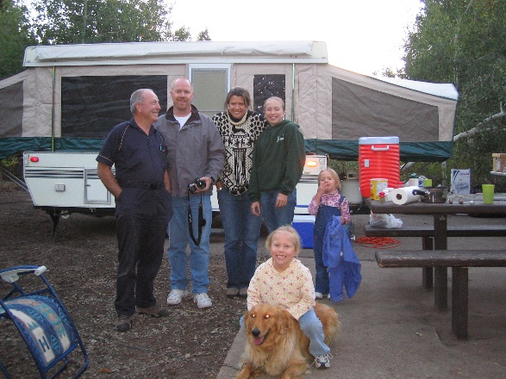Saturday to spend the day. David was studying hard as he was in medical school, but Shauna came and brought her kids. Mike, Becky and their family came that day too. I think Jeff, Gail & the children stayed the weekend with us. I can’t remember if Scott, Mishelle and their family came. Sandi came and I think she brought Dawson, but not sure if she did. It rained part of the time and cooled off at night. Sandi had brought her shade tent so we put it over the table and we played games under it even though it was raining. Shauna and the kids hadn’t brought jackets, but we had some extras, thank goodness as it was quite cold.

The remainder of the summer & fall was spent gardening, working in the yard, canning fruit and vegetables and spending time with our family and friends and tending grandchildren.

Ken and I are still the family history consultants for our ward. We have been able to help members with their family history & indexing and teach Family History classes.

**Hawaiian cruise with Shellie & Roy and Sandi in December 2012 – (I wrote this one, so decided to keep them both)**

Shellie called me I think in October and asked if dad and I would like to go on a Hawaiian cruse with them the first couple of weeks in December. It was a 14-day cruise. Ken and I talked about it, but decided not to go as we didn’t want to spend that much money, especially at this time of year and especially with it being such a busy month. We would be missing the ward and R.S. Christmas parties and other holiday activities and I had a lot to do to get ready for Christmas. Besides that, both Ken and I are allergic to gluten, dairy and sugar, so what fun would that be on a cruise & great vacation if we couldn’t have any of that which is in most of the food on the ship and in Hawaii. Shellie said that we could tell them when we signed up and they would make special meals for us which we could eat. Shellie called Sandi and Sandi wanted to go, but Nick couldn’t get off work and she didn’t want to spend that money on a cabin by herself. Shellie called me back and put more pressure on us, saying that Sandi wanted to go, but couldn’t unless we went too so we could share the cabin with her and it wouldn’t cost either of us so much. We finally decided to go. We did have a great time, however, since both Ken and I love frozen yogurt and they had those machines, we ate one now and then. Our meal hostess would come to our table each day and give us the special gluten/dairy free menu and help us plan our meals for the next day. We wouldn’t choose any desserts. The gluten free bread was terrible, so we didn’t eat much of that. We pretty much had the same meal each night: baked chicken, green salad, the same vegetables and our bread and water. It was hard when Sandi, Shellie & Roy could eat anything they wanted, but we stayed healthy most of the time, except that since Ken had eaten the frozen yogurt and fudged a little here and there, suddenly he was in pain. Shellie, Roy & Sandi had warned him not to eat anything he shouldn’t, but since he did and the scrambled eggs each morning had milk in them and he didn’t realize that, he had pain mainly the last day on the ship and wasn’t able to walk around, on the tours, like the rest of us. He had to stay on the tour bus some while Sandi & I got off and saw the sights. He did get off some, but his feet always hurt. I felt bad for him. We cruised over for four days and it was fun being on the ship. We went to the game room and played games when the weather was rainy or cold. When it was nice, we swam in the pool, sunbathed, sat in the hot tub, played miniature golf or shuffle board. Sandi and Shellie usually got up early and met at the gym and exercised and then went walking or jogging around the ship for more exercise. We all love to dance and they had a dance instructor each day who taught the fox trot, swing and other dances. We usually tried to go to those classes even though Ken and I didn’t need them. In fact, he told us that, but we told him we love to dance so enjoyed it anyway. Sometimes, Sandi, Shellie or myself would be his dance partner as his wife was in a wheelchair, but worked the music. Roy & Ken took turns dancing with Sandi too, plus other men asked her to dance. At night they had different entertainment in the main event center. One night they had a musician, one night they had a hypnotist and two nights each way they had the ships dancers and singers put on a show. They were good, but sometimes wore skimpy costumes. After the show, we would go to a dance floor where a Filipino dance band was playing. They had great voice too, especially the lead singer. They played songs that were great to dance to so we loved going there each night. Again, Roy & Ken danced with Sandi off and on too so she could have fun. She is a great dancer and her and her dad looked great together. I took lots of pictures.

We went to a different Hawaiian Island each day for five days and went on tours there. That was great! Roy & Shellie went on different tours as they had already signed up for them before we decided to go on the cruse. They went on a Helicopter ride one day, which was very expensive and she said there were clouds so they couldn’t see as much as they were supposed to. They went to the Polynesian Cultural Center another day. They went on a Mud Jeep Ride one day where they got really muddy and they went swimming with Dolphins one day. Sandi went on that with them and they went snorkeling one day. Ken, Sandi and I went to on several bus tours. One was to volcanoes, another to where a volcano had been and we climbed up a mountain to get to it. The tour bus drivers always were explaining things and pointing things out to us as we traveled. Another tour was to a place where the wind blows upward and they tell of a maiden who jumped off the cliff there and the wind blew her back. The wind was incredible there. We went on a fun Hawaiian boat ride down a beautiful river to a gorgeous jungle area where we walked down a path to an opening where we all stood and looked at the cave across from us. The foliage was beautiful. They have weddings there. A group of Hawaiian dancers and singers were there to perform for us, bus it started raining so they performed to us on our way back down the river. Another day the tour took us to a beautiful resort and beach. We sunbathed, swan and snorkeled. That was great fun as Ken and I had never been snorkeling before. It was great to see all the different fish underwater. That was a great day!! The last day we went on a walking tour around the city of Kaua. That was the day Sandi went on the “Swimming with dolphin’s tour” with Shellie & Roy. Sandi called us on our cell phone and she met up with us and then Ken went back to the ship as his feet were really hurting. Sandi & I went to gift shops and bought souvenirs. Sandi, Shellie & I went shopping one night after our tours. I bought a beautiful top which I wear a lot. I also bought Hawaiian dancing dolls for my granddaughters for Christmas. Sandi & Shellie bought them Hawaiian dresses and we all bought Leis to wear on ship for the Hawaiian dinner meal. We would eat breakfast, which was a delicious buffet and then go on our tours. Lunch was up to us, but we would have the dinner meal back on board the ship each night. We all had a great time. Hawaii is so beautiful and there is so much to see and do. The ship was beautiful too. Our cabin had a window where we could look out and see Tuna jumping, etc. Ken & I had a queen-sized bed and Sandi could either sleep on the couch or the bed which folded up in the wall. She did that the first few nights, but it was hard going up and down the ladder, so she finally just slept on the couch. It was great being with our daughters and Roy, we all had a great time together. I prayed for several years that our daughters would be close and love each other and want to be together. They are now and we are so grateful.